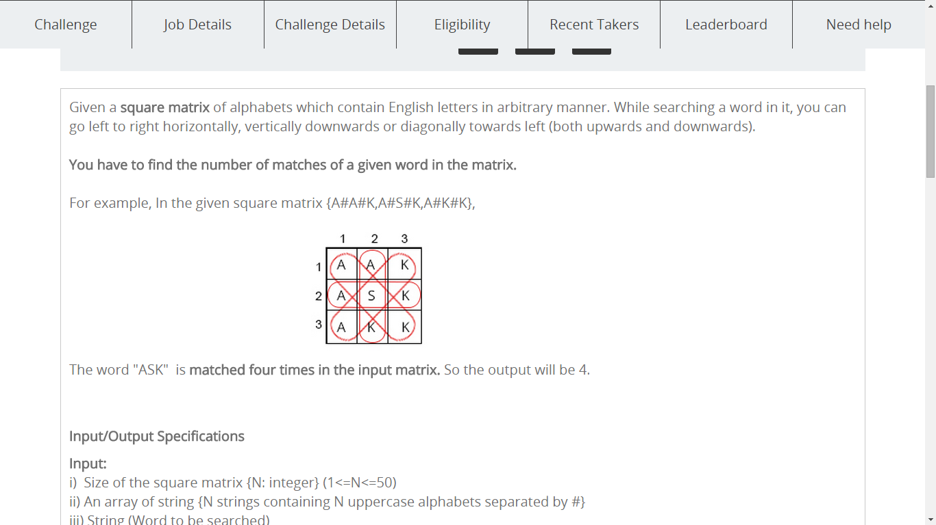

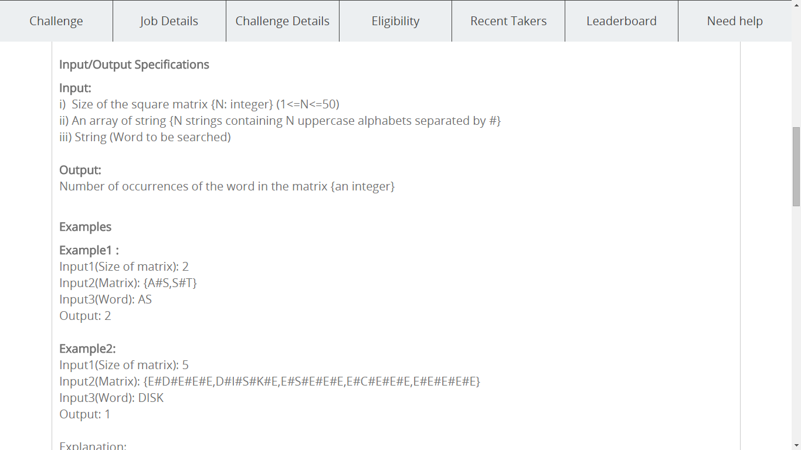

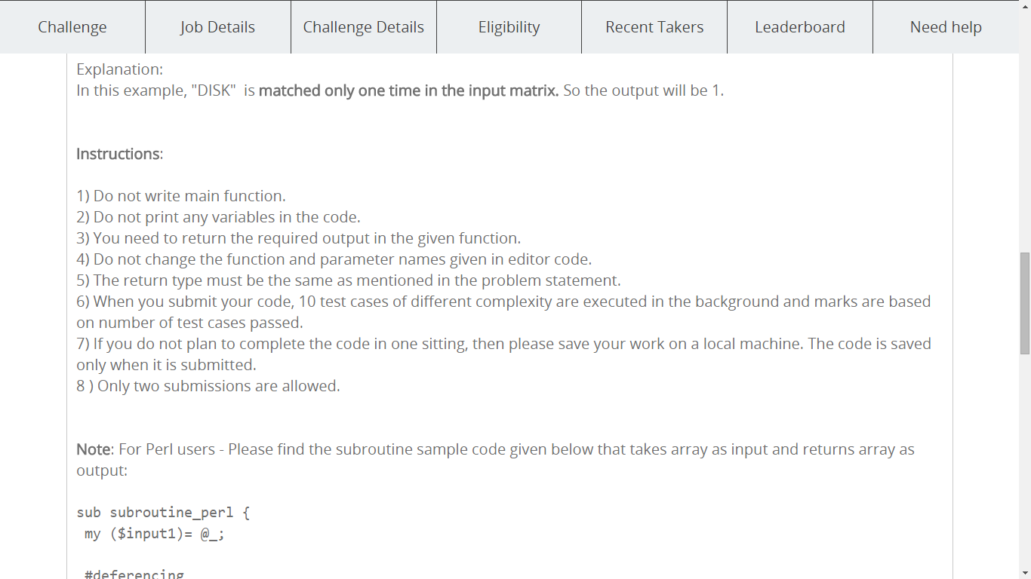

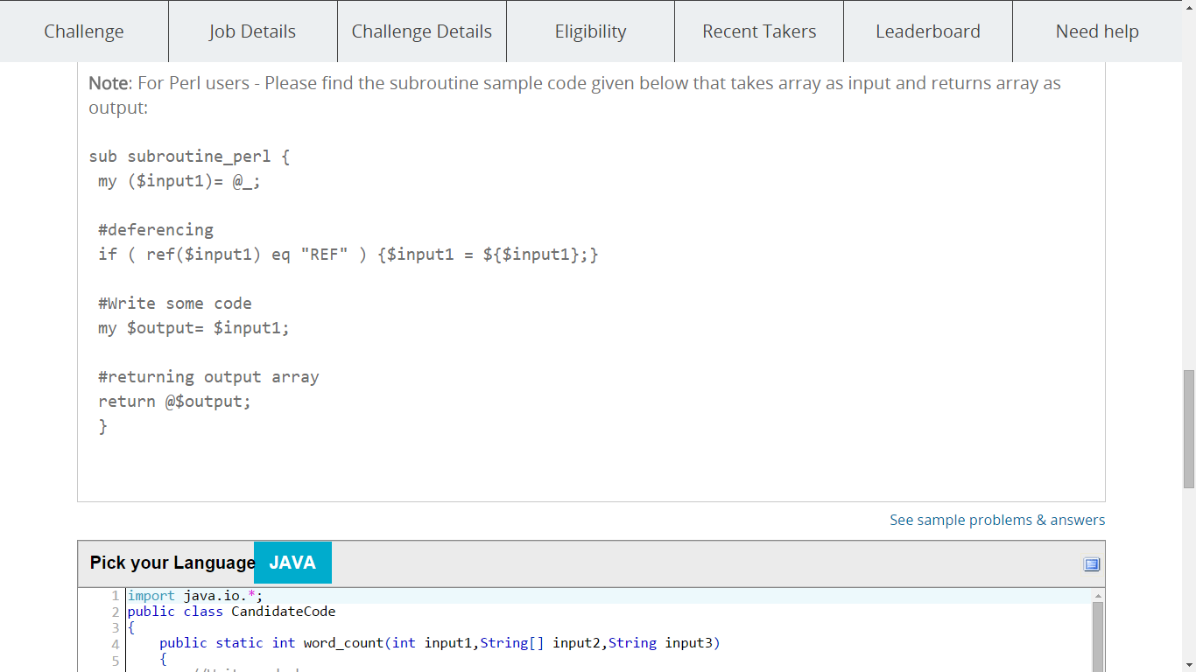

|  |
| --- |
| import java.io.*;  public class CandidateCode  {  public static int word_count(int input1,String[] input2,String input3)  {  //Write code here  }  } |